 Athlete Name:_____________________

Parent Name:______________________

Phone #___________________________

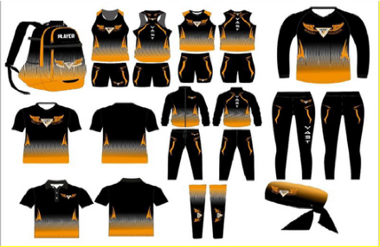$36 Boys Uniform Set (top & bottom)  
$36 Girls Uniform Set (top & regular bottoms)

$34 Backpack  
$26 Long Tights  
$54 Light Weight Jog Suit  
$22 Dri-Fit Polo (Unisex sizes adults)  
$22 Long Sleeve Dri- Fit (black or orange)  
$20 Dri-Fit Long/Short Sleeve “Do Not Retreat” (Unisex sizes)  
$32 Hoodie  
$10 Arm Sleeves

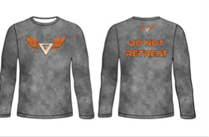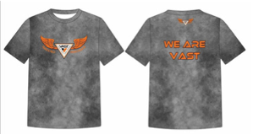$10 Headband

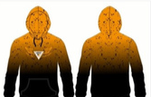Email form to vasttfcc@gmail.com

Send Payment:  
**Venmo:** @vasttrackclubtampa

**Orders are due NO LATER than the 15th of each Month**

**Please Note:  
*No Mix Matched Sizes*  
*Smallest available size is Youth 3x Small* *Sizes A2X and up is an additional $2 per item excluding uniform tops*  
*All adult sizes are unisex\***

Items

Size 3xSmall-Adult A2X

Item Price

Name on Backpack



Total: $________________